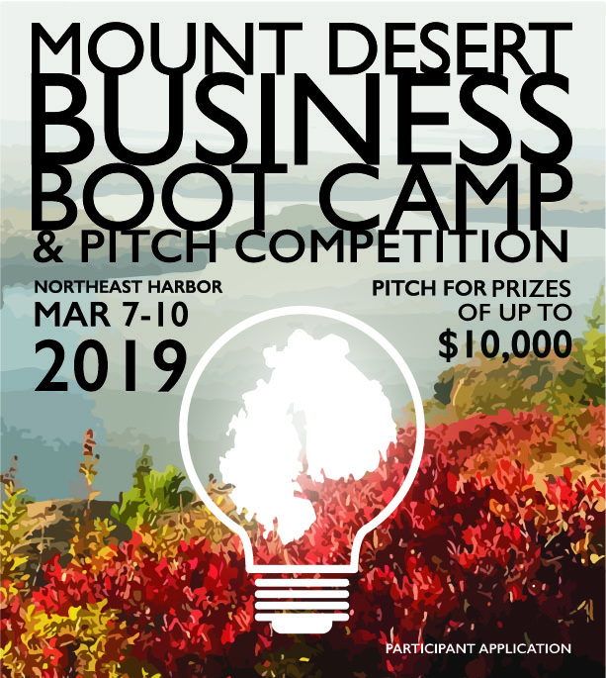

Mount Desert Business Boot Camp & Pitch Celebration
March 7 – 10, 2019
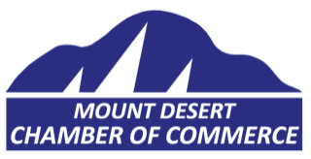
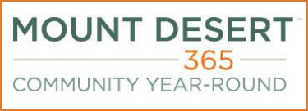
Presented by

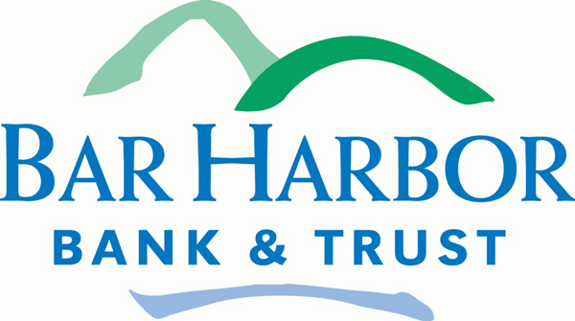
Sponsored by Facilitated by Jay Friedlander
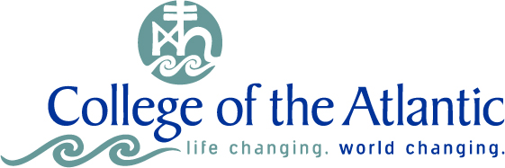

About the Boot Camp
- What: A three-day intensive training program for two participants from each enterprise, providing selected entrepreneurs the business skills and resources
needed to grow.
FREE
FOR
SELECTED BUSINESSES
- Who: Hancock & Washington county businesses, especially those
located in or serving the Town of Mount Desert year-round.
- Learn: Business essentials from industry experts including customer
value proposition, financials, solving business challenges, telling your
story, fundraising, and more.
- Win: The Boot Camp culminates with a pitch competition for an award up
to $10,000 from Bar Harbor Bank & Trust.

WHEN: March 7 - 10, 2019 | WHERE: Northeast Harbor

Eligibility
To be eligible to apply, enterprises must meet the following criteria:
- You have an established business located in Hancock or Washington county or are ready to launch.
- Special consideration will be given to year-round businesses.
- Two people from your enterprise are able to commit to three full days to participate in the training and
pitch celebration on March 8-10, with a welcome dinner the evening before on March 7. Training days start
at 8:45 am and end into the evenings with group dinners and working sessions. The pitch competition
takes place on March 10 at the end of the day.

Application Process & Deadline
Please answer each question below as specifically and succinctly as possible and email your completed application to community@mountdesert365.org no later than January 25, 2019 at midnight EST.
Accepted applicants will be notified by February 1, 2019.

Application

Contact Information (Applicants must be owners or members of the leadership team)
Business Name:
Contact Name:
Position/Title:
Phone Number:
Email Address:
Website Address:
Street Address:
City: |  | ZIP:
County:

Business Information
Provide a brief description of your business and your vision for its future growth.
Business Stage: |  | Established / Second Stage |  | Start Up
Number of Years in Business:
Number of Employees:
How would you classify your business? What industry are you in?

Market Demand
What trends lead you to believe this is a good business?
What unmet customer needs does your business’ product/services address?
Why do people use your product/service?
Please describe your target customer.
How large is the market for your products/services?
Who are your closest competitors, and what makes your products / services different?
Stage & Development of Venture
In what year was your business founded, and when did your business generate its first sale?
What makes you or your team qualified and capable of making this business successful?
How does your business earn revenue? How do you expect that to change in the long-term?
Please fill in the following:
 | 2015 | 2016 | 2017 | 2018 (projected)
Gross Sales | $ | $ | $ | $
Total Expenses | $ | $ | $ | $

Business Boot Camp Goals
What is the primary challenge your business is currently facing?
What would you expect to gain from participating in the Boot Camp that would help your business? Please be as specific as possible.
What are three things you would like to focus on during the Boot Camp that would help enhance your capacity to operate your business successfully?
1.
2.
3.
Please rate your level of competence with using spreadsheets, such as Microsoft Excel, and presentation software, such as Microsoft PowerPoint, by placing an “x” under the appropriate numbers below. Note, this will not impact your selection:
 |  | 1  (Novice) | 2 | 3 | 4 | 5  (Expert)
Spreadsheets
Presentation Software

Future Financing Needs
Please describe the expected short and long-term financing needs of your business.
If you receive the award of up to $10,000, which can be used for additional business assistance and/or capital expenditures, how would you plan to use it?

